**IST 263 Project Milestone 6 – First Draft Using CSS**

**Name**: Dawryn Rosario

**Description:**  
**Please paste your project description from Project Milestone 1 here.**

* For my semester long website project, I have decided to create a personal portfolio that introduces who I am, my plans and goals, and speaks about my internship this past summer. This website would have the aesthetics of a well-made website, as well as have the appropriate HTML links and tags for a navigation through the three pages of my website. My personal website will also have links to my contact information, like LinkedIn, email, etc. I also want a page of my website to highlight and explain some of my projects that I have worked on in the past.

**What is the url of the page you choose to work on for this part?**

* <https://dawrynrosario.github.io/ist263/projectdeliverables/projectHTML/index.html>

**Paste a screen shot of the wireframe you created for this page below.**

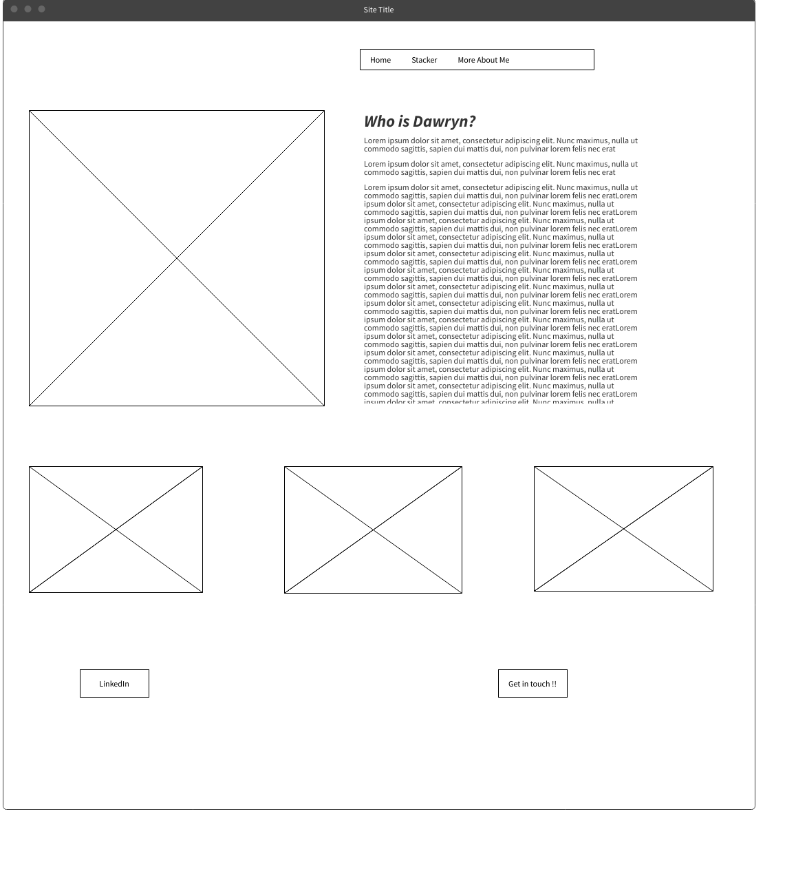

**Provide the URL of the WAVE checker for this page below.**

* <https://wave.webaim.org/report#/https://dawrynrosario.github.io/ist263/projectdeliverables/projectHTML/skeleton.html>

**Provide the URL of the HTML validator for you page below.**

* <https://html5.validator.nu/?doc=https%3A%2F%2Fdawrynrosario.github.io%2Fist263%2Fprojectdeliverables%2FprojectHTML%2Fskeleton.html>

**If something went wrong in this part, describe what happened and how you can fix it moving forward.   
Examples of problems could be, page isn’t responsive, page doesn’t look like wireframe, etc.**

* The only thing that went wrong was in a specific part of my code. When you check my HTML validator, it will bring up only one error, having to do with my interactive button on my website “get in touch !!”. I understand why and how it is an error, I am choosing to leave the error so I can get help with that aspect of my website. I want that button to take the user to my Contact page (the one we have been working on in lab the whole semester). Any help is greatly appreciated !!